Ifremer 2026 ISMS Modern firmware guide

This guide is specifically for the ISMS made for Ifremer in 2026. This model is modified slightly from prior ISMS versions and supports powering a cryotrap. The ISMS firmware documented here is a modern firmware available that follows a different command response structure which is easier to use and offers better debugging than the legacy ISMS style.

Firmware Install

The ISMS will come with the legacy firmware, to use the modern firmware, see the Ifremer 2026 ISMS notes document

Serial Studio Dashboard
ISMS Modern firmware has a visual dashboard that utilizes the free Serial Studio software found here: https://serial-studio.com
- Download the project file from here and open it in Serial Studio.
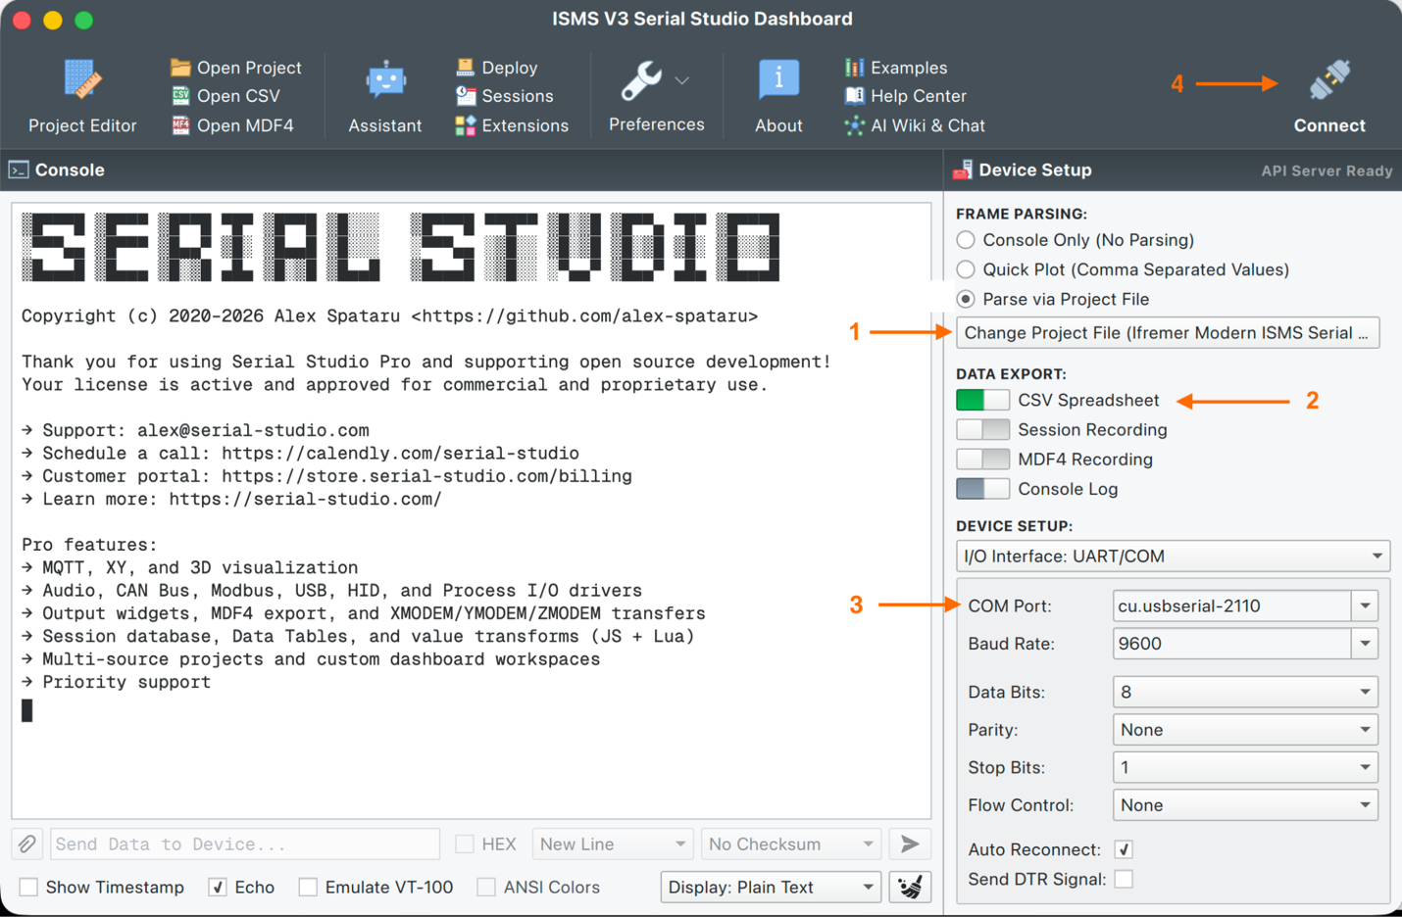
- Choose data export options to record the system data while the instrument is running.
-> CSV Spreadsheet and Console export options are recommended.
- Select the COM port for the ISMS with the shown options.
- Hit connect in the upper right -> If the com port is correct, The ISMS will restart and you will see “Waiting for startup…” followed by more lines and the dashboard will open. If you see garbled messages, nothing, or data is not updating try a different com port, ensure serial parameters are as shown or try adding a null modem plug to the RS232 lines - RX & TX get swapped all the time.
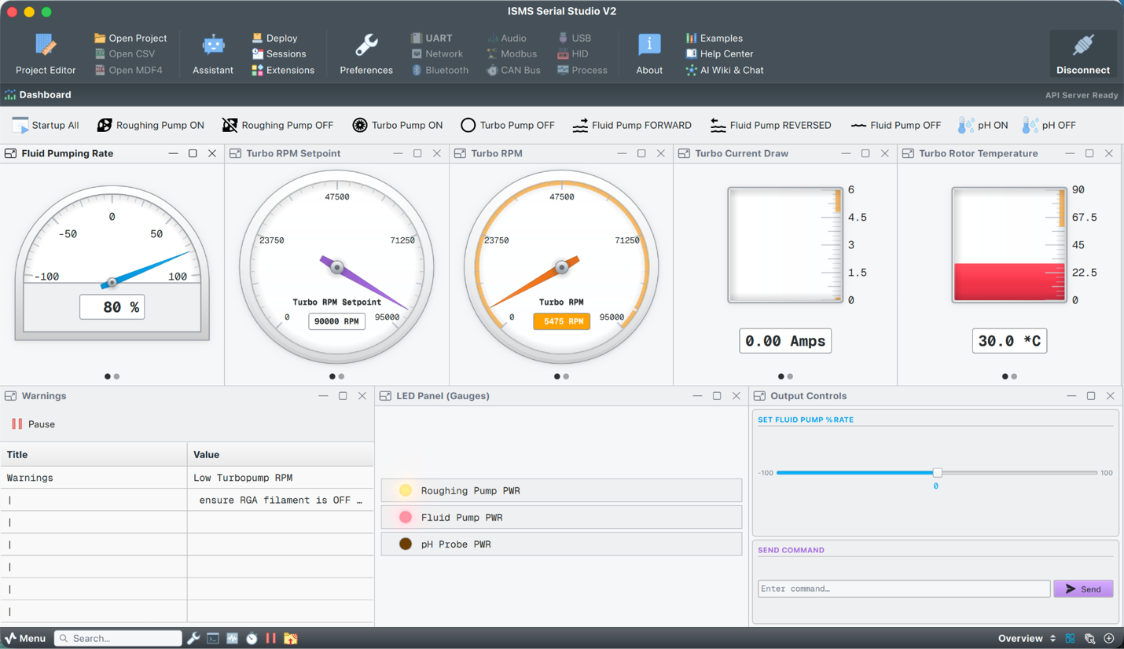
The dashboard should look like this - if the raw console opens in a new window, you can safely close it.
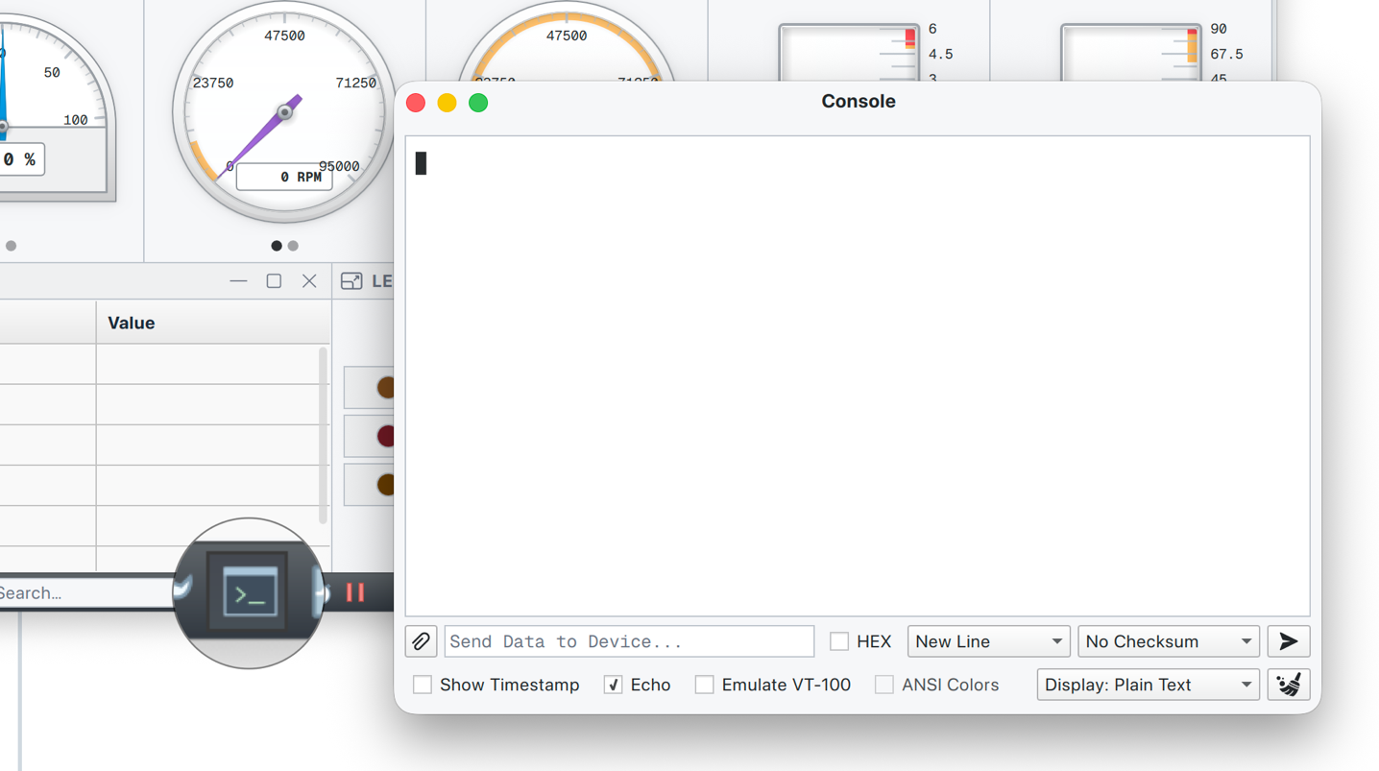

At the top are action buttons for controlling the ISMS:
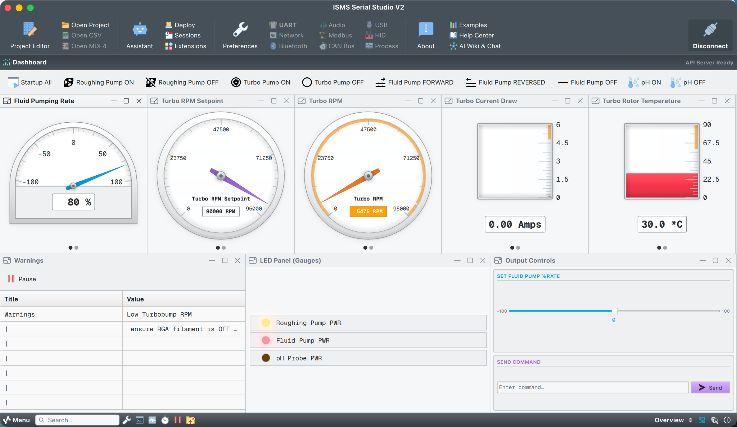
In the bottom left corner are any active warnings coming from the ISMS as well as utility buttons such as to open the raw serial console, a stopwatch, a play/pause control for the incoming data, etc.… | In the lower right corner, you can choose different views of the data such as plots or the default overview.
 | 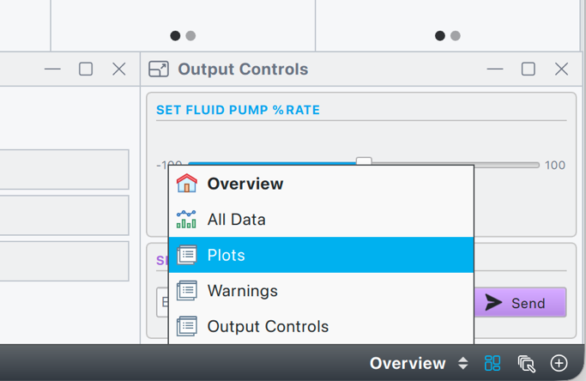
To access the command line interface of the ISMS, use the console button. Commands can be typed in the box at the bottom, and the output will be displayed on the console.
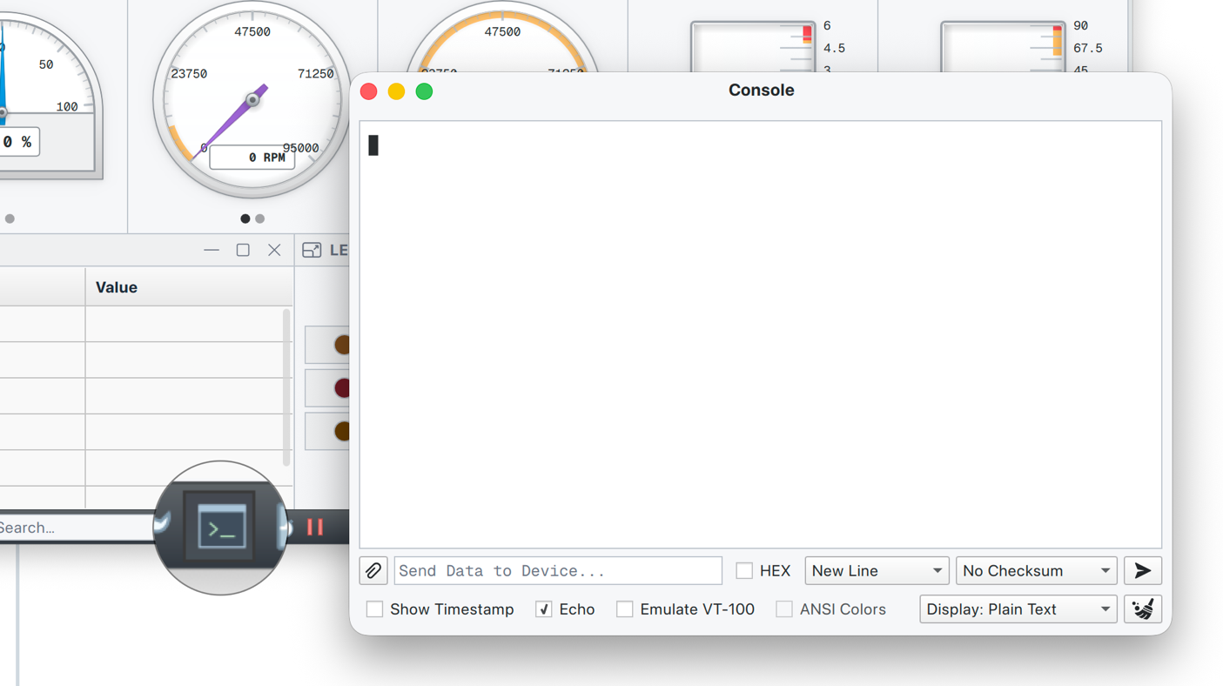

Command Line Interface

